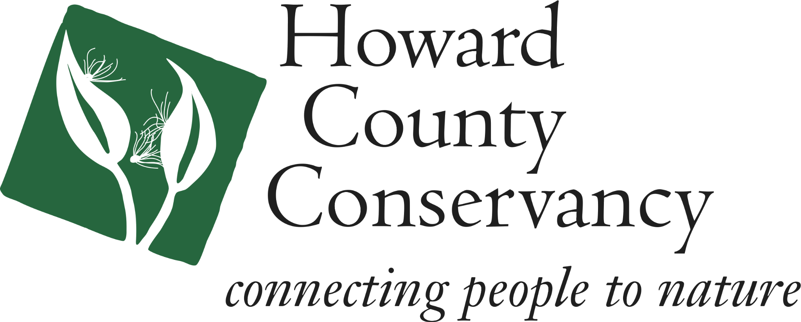

Wine in the Garden/
Beer in the Barn
2024 Auction Donation Form
2024 marks the 17th annual fundraiser, Wine in the Garden, Beer in the Barn. On September 19th, from 5 to 8 p.m., guests will stroll through the John L. Clark Honors Garden, listen to local bluegrass music, sample wine, beer & food and support a great cause. Silent auction items support our environmental education and preservation programs and help us connect over 40,000 people to nature each year.
Thank you for donating and contributing to our success!
Name: __________________________________________________________ Address:__________________________________________________________ Phone: _________________________ Email ________________ ________ Item(s) donated:____________________________________________________ Description of item(s):________________________________________________ _________________________________________________________________ _________________________________________________________________ Approximate value:_____________________________
Name or business exactly as you would like to be recognized in program:
___________________________________________________________________
Return this completed form promptly. However, donated items should be mailed, dropped off or delivered prior to 9/1/24
Please return this form to Susan.Hobby@howardnature.org or drop off with your donation.
Each year the Howard County Conservancy helps over 30,000 people connect with nature. We are open to the public for numerous programs and special events throughout the year and hold conservation easements on 2,000 acres. Our 232-acre headquarters in Woodstock offers 5 miles of trails for all to enjoy. The Conservancy is a local, non-profit organization and donations are tax-deductible to the full extent protected by law. Our tax ID is 52-1712913.
The Howard County Conservancy / 10520 Old Frederick Road, Woodstock, MD 21163 / 410-465-8877

